

HOSTEL MANAGEMENT SYSTEM

Object-Oriented Programming (C++) Project Report

Submitted To
Sir Khawaja Badar

Submitted By
- Bilal Abid Abbasi
- Hubaib Khan
- Muqtadir Khan

Institution
Iqra University

Course
Object-Oriented Programming Lab (C++)

Submission Date
9 JUNE 2026

Abstract
The Hostel Management System is a console-based application developed in C++ using Object-Oriented Programming (OOP) concepts. The system is designed to manage hostel student records efficiently by providing facilities for student registration, searching, updating information, room allocation, fee management, and record deletion.
Traditional manual record management systems are often time-consuming and prone to errors. This application automates hostel administration tasks, improves record accuracy, and provides quick access to student information. The project demonstrates practical implementation of inheritance, polymorphism, encapsulation, classes, objects, and data management techniques in C++.

1. Introduction
Hostel management is an important administrative task in educational institutions. Maintaining student records manually can result in data duplication, record loss, delays in information retrieval, and inefficient management of hostel resources. As the number of students increases, managing accommodation details, room allocations, fee records, and student information becomes more challenging. Therefore, there is a need for an automated system that can efficiently handle hostel-related operations.
The Hostel Management System provides a computerized solution for managing hostel records. The system allows administrators to add student information, search records, update fees and room assignments, display student details, and remove records when required. By automating these tasks, the system reduces paperwork, minimizes human errors, and improves the overall efficiency of hostel administration.
The project has been developed using C++ and follows Object-Oriented Programming (OOP) principles to ensure modularity, maintainability, and code reusability. The use of classes and objects helps organize the program into manageable components, making it easier to understand, modify, and extend in the future.
The system is designed to maintain accurate records of hostel residents, including personal details, room numbers, contact information, and fee status. It provides quick access to data and enables administrators to perform operations efficiently without searching through large amounts of paperwork. The system also improves data consistency and security by storing information in a structured format.
Furthermore, the Hostel Management System serves as a practical application of programming concepts such as classes, inheritance, encapsulation, file handling, and data management. It demonstrates how software solutions can be used to solve real-world administrative problems and enhance organizational productivity.
The primary objective of this project is to develop a user-friendly, reliable, and efficient hostel management application that simplifies hostel administration, improves record management, and supports better decision-making for hostel authorities.

2. Problem Statement
Manual hostel management systems suffer from several limitations:
- Difficulty in maintaining student records.
- Time-consuming record searching.
- Errors during room allocation.
- Inefficient fee management.
- Increased paperwork.
- Lack of centralized information storage.
The proposed Hostel Management System aims to automate these tasks and improve overall administrative efficiency.

3. Objectives
The objectives of the Hostel Management System are:

3.1 Student Record Management
Store and maintain student information digitally.

3.2 Room Management
Assign and update hostel room numbers.

3.3 Fee Management
Maintain hostel fee records and update payments.

3.4 Search Facility
Quickly search student records using Student ID.

3.5 Record Maintenance
Modify and delete student records whenever required.

4. Scope of the Project

Included Features
- Add Student Records
- Display Student Records
- Search Student by ID
- Update Student Fee
- Change Room Number
- Delete Student Record

Future Enhancements
- File Handling for Permanent Storage
- Database Integration
- Online Fee Management
- Student Login Portal
- Web-Based Hostel Management System

5. Methodology
The project was developed using the Object-Oriented Programming approach.

Requirement Analysis
The following entities were identified:
- Person
- Student
- Hostel

System Design
The system was divided into classes where each class performs specific tasks.

Implementation
The project was implemented using:
- Classes and Objects
- Inheritance
- Polymorphism
- Arrays
- Input Validation

Testing
Each module was tested separately to verify correctness and functionality.

6. System Design

Class Structure

Person Class
Base class containing:
- Name
- Age

Student Class
Derived class inherited from Person.
Additional attributes:
- Student ID
- Father Name
- CNIC
- Contact Number
- Room Number
- Hostel Fee

Hostel Class
Manages all student records and provides operations such as:
- Add Student
- Display Students
- Search Student
- Update Fee
- Update Room
- Delete Student

7. Functional Requirements

Student Registration Module
- Enter student information.
- Store student details.

Search Module
- Search students using Student ID.

Fee Management Module
- Update hostel fee records.

Room Management Module
- Change room assignments.

Record Deletion Module
- Remove student records when required.

8. OOP Concepts Implemented

8.1 Classes and Objects
Classes used:
- Person
- Student
- Hostel
Objects are created from these classes to perform operations.

8.2 Encapsulation
Private data members are used to secure sensitive information such as:
- Student ID
- CNIC
- Contact Number
- Fee
Access is provided through public member functions.

8.3 Inheritance
Student class inherits common attributes from Person class.
Example:
Student → Person
This reduces code duplication.

8.4 Polymorphism
Runtime polymorphism is implemented using:
- Virtual Function
- Function Overriding
The display() function in Student overrides the display() function of Person.

9. Program Workflow
- User launches the application.
- Main menu appears.
- User selects an operation.
- Student records are added or modified.
- Fees and room information are updated.
- Student records are searched.
- Records can be deleted when necessary.
- Program exits upon user request.

10. Output Screens
(Insert screenshots of your program output here)
Main Menu
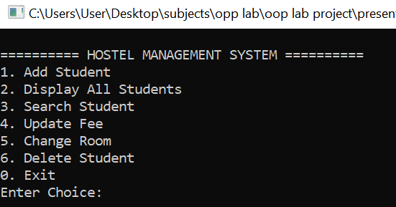
Add Student
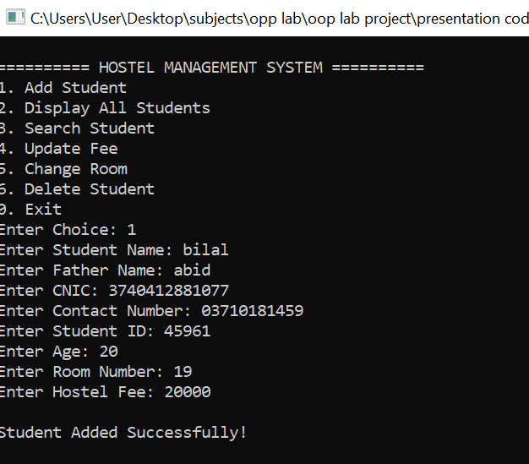
Search Student
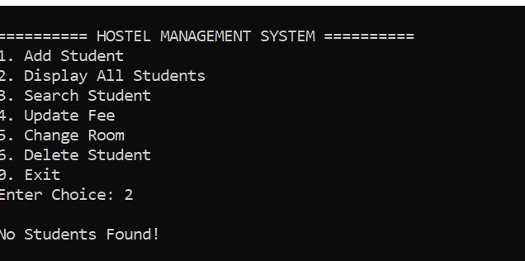
Update Fee
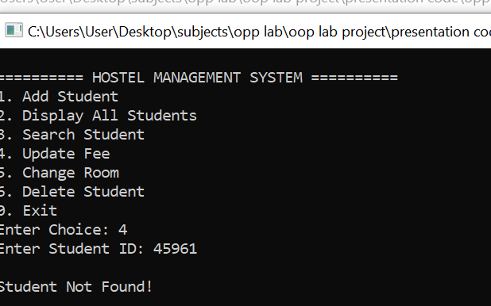
Display Records
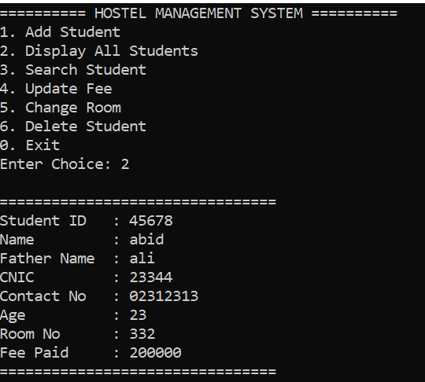

.

11. Advantages of the System
- Faster record management
- Easy student searching
- Improved accuracy
- Reduced paperwork
- Better room allocation management
- Efficient fee tracking
- User-friendly interface

12. Limitations
- Data is stored only during program execution.
- No database integration.
- No file handling.
- Limited hostel capacity (100 students).

13. Conclusion
The Hostel Management System successfully demonstrates the practical implementation of Object-Oriented Programming concepts in C++. The system provides an efficient solution for managing hostel records through student registration, searching, fee management, room allocation, and record deletion.
The project improves administrative efficiency and serves as a strong example of applying inheritance, polymorphism, encapsulation, and modular programming techniques in real-world applications.

14.References
- Object-Oriented Programming in C++
- C++ Programming by Bjarne Stroustrup.
- C++ Standard Library Documentation.
- Object-Oriented Programming Course Notes.

